Wisconsin Idea Internship Program (WIIP)

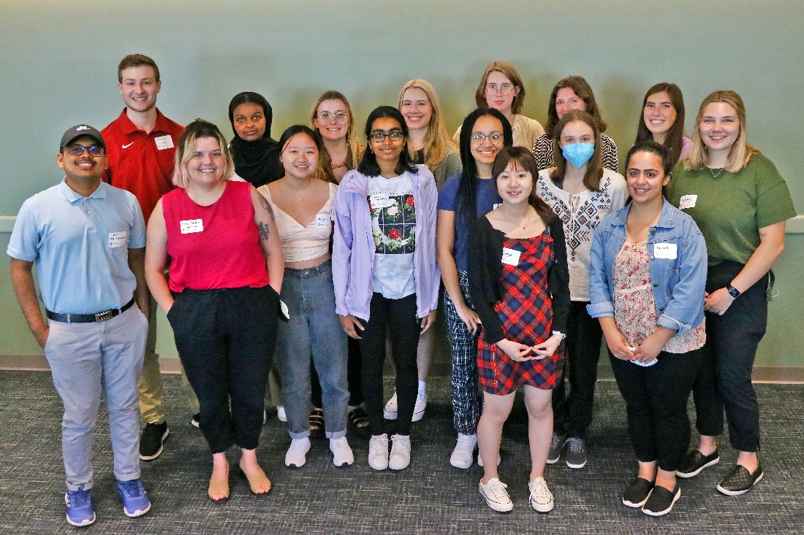

Wisconsin Idea Internship Program
Request for Position Proposals

Purpose
We are requesting proposals for paid summer internship positions from Extension faculty and staff.

WIIP overview
The Wisconsin Idea Internship Program (WIIP) is a talent development pipeline initiative sponsored by the University of Wisconsin-Madison’s Division of Extension and the Division of Diversity, Equity, and Educational Achievement (DDEEA). WIIP offers paid summer internship opportunities and is open to current undergraduate and graduate students pursuing a degree-granting program in any School or College at UW-Madison. This program is intended to holistically develop the professional skills and interests of current students, provide them with opportunities to contribute to our organization’s programs and activities, and encourage them to explore potential career paths in Extension.

In alignment with UW-Madison’s institutional statement, the Division of Extension considers diversity to be a source of strength, creativity, and innovation. We value the contributions of each person and respect the profound ways their identity, culture, language(s), background, status, abilities, experiences, and perspectives enrich the university community. We commit ourselves to the pursuit of excellence in teaching, research, outreach, and diversity as inextricably linked goals.

Program objectives
The WIIP has two strategic objectives:
- To create meaningful employment opportunities that help interns:
  - Build professional skills, talents, and assets that prepare them for future employment and career paths, both within and beyond Extension
  - Connect with, and contribute to Extension-sponsored programs, services, projects, and research efforts around the state
  - Explore how university-based research and traditional forms of knowledge are applied to serve and benefit the needs and interests of Wisconsin communities
  - Understand the important function of Extension both in Wisconsin, and its place at other U.S. Land-Grant Universities (LGUs)
- To attract and develop candidates whose background, skills, and assets enrich Extension as a diverse and inclusive workplace. This includes, but is not exclusively limited to, strategic encouragement and recruitment of applications from:
  - Persons from racially, ethnically, linguistically minoritized communities
  - Members of tribal nations who reside on or near tribal lands
  - Persons with diverse abilities
  - Persons with veteran status
  - Returning adult students and persons with non-traditional student backgrounds
  - Areas of study and careers where women have been historically underrepresented (e.g. science, technology, engineering, and math [STEM], and others)
Internship program scope
Extension will provide funding for up to 20 successful internship proposals. Internships will take place during the summer and are intended to last approximately three months. All interns are classified as student hourly employees. Each intern will be compensated at a rate of $15 per hour. Interns can earn up to $8000 over the course of the summer. The internship starts in late May/early June and concludes at the end of August. Where applicable, funding is available to support intern travel to and from internship or programming site.

Student Intern eligibility
The Wisconsin Idea Internship Program is open to all undergraduate and graduate students pursuing a degree-granting academic program at UW-Madison. Students with part-time or full-time enrollment status may apply. All applicants must be able to verify their enrollment at UW-Madison for fall semester of 2023. Students graduating in May 2023 are not eligible to apply for WIIP internships.

Supervisor expectations
An intern’s supervisor of record must be an Extension employee. These are formal internships where the student will work under their supervisor/mentor. In other words, all work must be directed by the intern’s supervisor of record. All supervisors are responsible for approving payable hours and helping interns address any questions during they summer employment. In addition to established duties and responsibilities associated with the intern’s position, supervisors are expected to take an active role in mentoring and supporting their interns during the experience. This includes attending the orientation, midpoint check-in, and showcase event.

Recommendations for position proposals
Supervisors/mentors are responsible for identifying duties and responsibilities as a part of their proposals. We encourage internships to be flexible in their initial design. The design of the position can fall into one of three main categories:
- 100% on-site work arrangement (e.g. Extension office)
- 100& remote work arrangement
- Hybrid arrangement (a combination of on-site and remote work)

This internship program is open to all students pursuing their studies and degree in any School or College at UW-Madison. We recognize that some internship opportunities may align closely with certain academic disciplines or majors. Thus, it is appropriate to identify and include relevant areas of study or academic interests as a part of the proposal. However, we encourage supervisors/mentors to avoid developing proposals for positions that exclusively seek to recruit applicants based on specific majors or academic disciplines.

WIIP Program components
- In-person orientation for interns and supervisors (Location: Madison, WI)
Objectives and focus
  - Introduction to Land-Grant Mission and the U.S. Land-Grant University system
  - Introduction to the Division of Extension and its core programs and activities
  - Professional networking opportunities
- Mid-summer check-in for interns and supervisors (via Zoom or in-person)
  - Sharing experiences
  - Professional networking opportunities
  - Provide guidance and direction on the internship report/summary
- Internship showcase event for interns, supervisors/mentors, and special guests (Location: Madison, WI)
  - Celebrate interns and showcase their work
  - Wrap-up the WIIP experience
- Internship project report/summary
  - At the conclusion of their employment, each intern is expected to produce and present a report/summary of their work with guidance and support from their supervisor/mentor. This will be used as a part of the WIIP Showcase Event. The report/summary can include:
    - Identifying the project or issue
    - The intern’s involvement on the project or addressing the issue
    - What interns learned during their employment with Extension or working with their supervisor/mentor
    - How the internship experience will benefit the intern’s future goals and professional trajectory. Note: Interns based in county offices will be expected to present a summary of their work and experience to stakeholders or stakeholder groups that have an interest in the work.

Proposal criteria and evaluation
Position proposals will be evaluated by members of the WIIP Steering Committee. Members of the Dean’s Leadership Team, Institute Directors, and Area Extension Directors may also be consulted during the process of reviewing proposals and making funding recommendations.

The committee’s evaluation and selection of funded internships will be guided by the following questions:
- Does the internship proposal align with the strategic objectives of the WIIP?
- Does the proposal clearly identify an existing or emerging issue/need in Extension?
  - If so, in what ways will this position, and its respective duties, help address the issue/need?
- How or in what ways does the proposal offer the intern opportunities that deepen their understanding of Extension as an organization, and our programs, services, projects, and research activities?
- If funded, how could this internship opportunity holistically support and advance an intern’s professional experience, goals, skills, talents, and assets? In other words, what are the range of benefits this type of position has to offer an intern?

For funded proposals, supervisors will have opportunities to “co-establish” a set of mutually beneficial goals and learning outcomes with the intern. This will allow supervisors/mentors to further refine a scope of work that is informed by the hired intern’s professional interests, skills, and assets.

Submitting proposals
Position proposals must be submitted by the internship supervisor of record. Position proposals are submitted through Qualtrics using this link: 2023 WIIP Proposal Application.

For full consideration, proposals must be received no later than Friday, December 30, 2022.

Overview – Proposal review and notification process
- Extension employee submits an internship proposal through Qualtrics form
- WIIP Steering Committee reviews proposals
- Steering Committee makes a recommendation
  - Recommend proposal for funding (as is)
  - Conditional recommendation (proposal revisions or clarification needed)
  - Not recommend proposal for funding
- Committee provides notification to those who submitted proposals
- Batch of 2023 WIIP positions are confirmed

See below for full WIIP 2023 timeline.

Funded proposals
Notification of selected proposals will be made by January 20, 2022. Extension HR will collaborate with Supervisors of funded internships to post the position to the UW Student Job Website by February 15, 2023 to align with the WIIP’s strategic recruitment efforts on UW-Madison campus and elsewhere. See accompanying timeline for further details.

Student Recruitment
Those who receive funding for an internship are expected to be diligent in marketing the Wisconsin Idea Internship Program opportunities to potential applicants, including those from the groups listed in the program’s objectives. Additionally, WIIP coordinators will work with DDEEA staff to identify and leverage campus-based relationships that support the WIIP marketing and recruitment process.
Wisconsin Idea Internship Program Timeline
UW-Madison Division of Extension

Activity | Due Date*
Initial RFP email to all staff | November 30
WIIP Proposal Office Hours | December 12- 30
Deadline for submitting position proposals (online application) | December 30
Notification of successful proposals | January 20, 2023
WIIP Supervisor Orientation | February 1: 1pm-3pm
Positions posted to UW Student Jobs website | February 15
Student recruitment begins | February 15
Student application deadline | April 15
Student interviews | April - May
In-person orientation (1st day of paid work) | June 1
Internship employment period | Approx. June 1 – August 30
Mid summer check-in | Early to mid July
Final showcase event | Mid to end of August
Program evaluations/project reports | September 15

*If date falls on a weekend or holiday, due date will be next business day.

UW-Madison Division of Extension Wisconsin Idea Internship Program
Position Application

[via online form in Qualtrics]

- Office or unit interested in hiring intern:
- Intern supervisor/mentor information (Name, title, email)
¨ By checking this box I affirm that I have discussed my intent to submit a position proposal with my supervisor and have their support.
Name of backup supervisor____________________
- What is your Institute or primary Extension affiliation?
- Agriculture
- Community Development
- Health & Well-Being
- Human Development and Relationships
- Natural Resources
- Operations (HR, Communications, ETS, OFS, OAIC)
- Positive Youth Development
- Covering Wisconsin
- Center for Patient Partnerships
- Location of internship (county [if applicable], street address, city):
- Proposed internship position title:
- Duration of internship (estimated start date, number of weeks, estimated hours per week):
- Based on your project or scope of work, what arrangement do you think would work best for the position you are proposing?
  - 100% on-site work arrangement (e.g. Extension office)
  - 100% remote work arrangement
  - Hybrid arrangement (a combination of on-site and remote work)
  - I am not sure at this time
- Amount of funding requested for this position (up to $8000):
- Please describe the project and/or an identified issue/need that you want to address. How will an intern collaborate on the project and/or help address the issue/need you identified? (maximum of 2000 characters):
- Please provide a description of the proposed internship’s core functions, responsibilities, and duties (maximum of 2000 characters):
- Please list any desired knowledge, skills, and/or experience a strong applicant for your position might possess (maximum of 1000 characters):
- Are you expecting the intern to travel to carry out their position duties?
- In order to target our outreach and recruitment, please check Schools or Colleges that you feel are relevant to students who might be interested in your internship position (check all that apply):

- Agricultural and Life Sciences
- Arts
- Business
- Computer Science
- Education
- Engineering
- Environmental Studies
- Human Ecology
- Information
- Journalism & Mass Communication
- Law
- Letters and Science
- Medicine and Public Health
- Nursing
- Pharmacy
- Public Affairs
- Social Work
- Veterinary Medicine
- Other ______________

- Please list up to 10 “tag words” that an applicant might find interesting about this position:
For example, if I wanted to hire a communications intern to work in Extension’s Office of Communications and Stakeholder Engagement, tag words might include “strategic communications, marketing, website development, social media, brand management, etc.”

See Equal Employment Opportunity Commission (EEOC) Notice No. 915.027 (May 16, 1988)
See Recruiting, hiring, retaining, and promoting people with disabilities: A resource guide for employers (February 3, 2015)
See Equal Employment Opportunity Commission (EEOC) Notice No. N-915.056 (August 10, 1990)
All supervisors and time approvers must be employed by the Division of Extension

