Click here to enter date.
Name and address of partner organization

Dear Name of contact person at partner organization:
This letter serves as a notification and periodic reminder that the UW-Madison Division of Extension does not discriminate in the treatment of individuals in admission or access to its programs and activities, in the provision of services, or in employment. In accordance with federal law and U.S. Department of Agriculture (USDA) civil rights regulations and policies, Extension is prohibited from discriminating on the basis of race, color, national origin, sex, age, or disability.
Therefore, as an institution receiving federal financial assistance through the USDA, Extension cannot partner with any organization that intentionally discriminates on the basis of any of the legally prohibited categories of discrimination outlined above.
A partner organization is defined as a group of people that Extension works with or anticipates working with that:
- Participates in the planning, development and/or delivery of an educational program or service;
- Provides access to a specific audience;
- Provides a facility or physical space at which an Extension program or activity is held; or
- Sponsors or provides any sort of financial or in-kind support for an Extension program or activity.
To help us ensure that our partners do not intentionally discriminate, we ask that an officer of your organization sign and return the enclosed Assurance of Nondiscrimination by Partner Organization.
On behalf of Enter name of county County Extension, I want to thank you for collaborating with Extension on educational programs. We appreciate your support and partnership as we provide education designed to meet the needs of our diverse community members.

Sincerely,

Name of Extension educator working with partner organization

 | 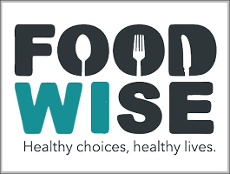 | MASTER GARDENER | 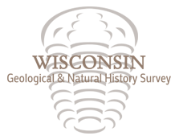

County office name and address here

Assurance of Nondiscrimination by Partner Organization

UW-Madison Division of Extension, which receives federal financial assistance, cannot partner with or provide assistance to an organization that excludes any person on the basis of protected categories outlined in civil rights laws.
A partner organization is defined as a group of people that Extension works with or anticipates working with that:
- Participates in the planning, development and/or delivery of an educational program or service;
- Provides access to a specific audience;
- Provides a facility or physical space at which an Extension program or activity is held; or
- Sponsors or provides any sort of financial or in-kind support for an Extension program or activity.
To assure compliance with this nondiscrimination requirement, we ask that an officer or other appropriate representative of your organization sign and return the following statement on behalf of the organization to the above address. If your organization has a formal nondiscrimination policy, please include a copy of it when you return this form.

I certify that Enter name of organization does not intentionally exclude, restrict, or deny any person membership or participation in its activities because of race, color, national origin, sex, age, or disability.

Signature ___________________________________________________________

Enter name and title
Click here to enter date

