Instructor Guide
Challenge Title: X Marks the Spot
Introduction
This robotic challenge uses a challenge mat. The robot configuration must include the touch sensor and the ultrasonic (distance) sensor. The obstacle listed on the challenge schematic can be a wall or any other object that will not move when struck by the robot, but it must be at least nine (9) inches in height to activate the ultrasonic sensor (on the basic robot). The participants will not be told the distance from the obstacle to the X for steps 4-5. They will need to use trial-and-error to calculate the proper travel duration of the robot. For example, they might have to view how far the robot travels in one tire rotation and then estimate how many rotations it will take to cover the required distance. The youth will also have to use trial-and-error to figure out how to make the robot turn the correct arc distance so the touch sensor is facing the obstacle after the robot spins on the X in step 6. They may also reference “Distance and Turns” to estimate how many rotations or degrees it will take to successfully complete the challenge.
Objectives
Youth will demonstrate creativity, innovation and critical thinking skills.
Youth will increase their ability to work collaboratively with others.
Youth will be able to improve communication skills.
Youth will better understand the process of programming and evaluating robotic movements.
Youth will increase their ability to design a solution to a challenge.
Level of Difficulty
Preparation and Materials
Instructor should determine the teaching methodology (as identified in the introduction of this guide) that best fits the audience.
Print appropriate student materials.
Create “X Marks the Spot” challenge mat using:
Masking or painter’s tape
Measuring tape
Paper or poster board (at least 50 X 12 inches in size)
Obstacle such as a weighted box, heavy book, or wall at least nine inches in height
44 inches
obstacle
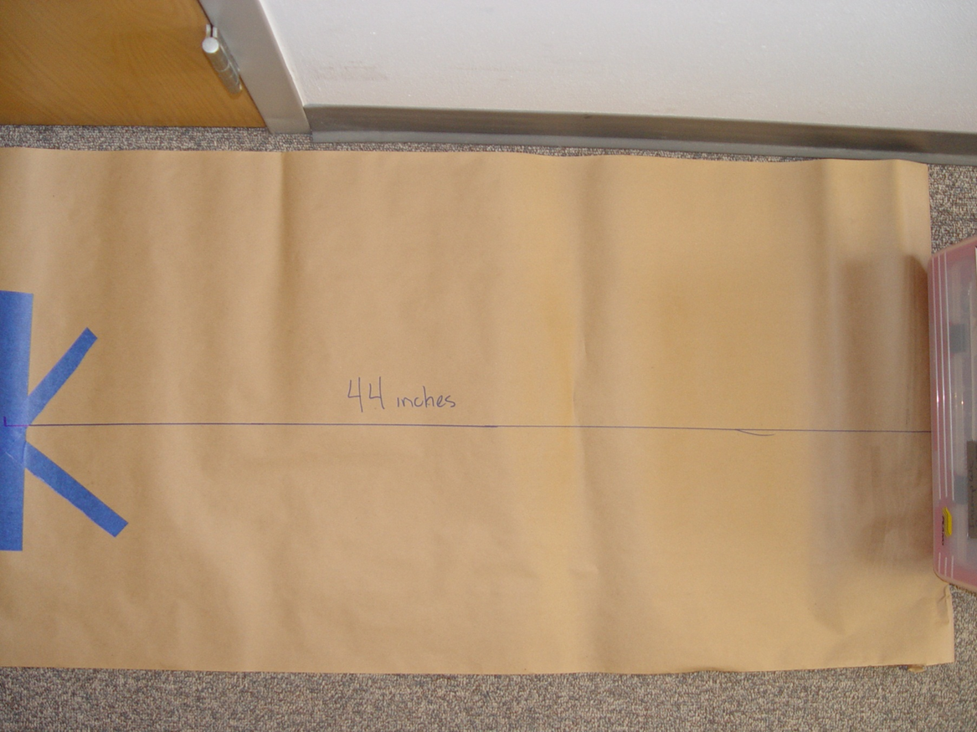
Time Required
Programming: 45 minutes – 1 hour (if participants are given text instructions only).
To run the course: 2-3 minutes.
Procedure of Programming Steps
Depending on the expertise level of the participants, the instructor can give the youth the text of the steps involved in the challenge, give them the abbreviated programming guide or give them the entire pictorial programming guide.
TEXT:
- The robot begins the challenge centered on the X facing toward the obstacle (ultrasonic sensor facing obstacle).
- The robot moves toward the obstacle.
- The robot uses the ultrasonic sensor to detect the obstacle at a distance of 12 inches.
- Upon sensing the obstacle the robot moves backwards.
- The robot stops in its original position (centered on the X as in step 1).
- The robot spins in place 2 and ½ times such that the touch sensor is now facing the obstacle.
- The robot moves toward the obstacle.
- The robot touches the obstacle with the touch sensor.
- The robot travels back to the X and stops when centered on the X.

ABBREVIATED PROGRAMMING GUIDE:
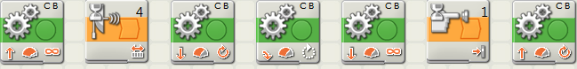
COMPLETE PICTORIAL PROGRAMMING GUIDE:
- The robot begins the challenge centered on the X facing toward the obstacle (ultrasonic sensor facing obstacle).

- The robot moves toward the obstacle.
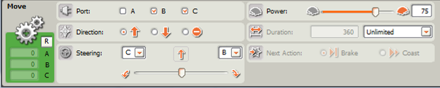
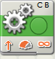

- The robot uses the ultrasonic sensor to detect the obstacle at a distance of 12 inches.

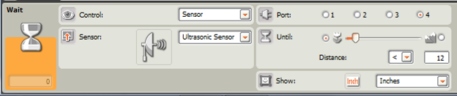

- Upon sensing the obstacle the robot moves backwards.
- The robot stops in its original position (centered on the X as in step 1).
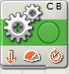
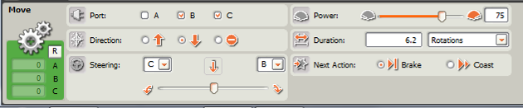

- The robot spins in place 2 and ½ times such that the touch sensor is now facing the obstacle.
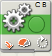
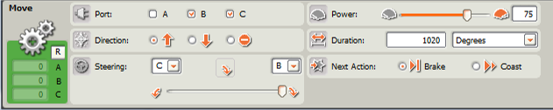

- The robot moves toward the obstacle.
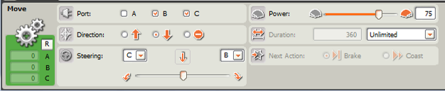
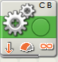

- The robot touches the obstacle with the touch sensor.
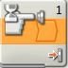
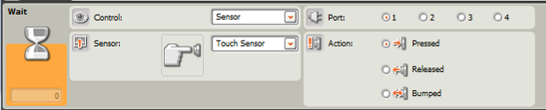

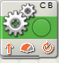
- The robot travels back to the X and stops when centered on the X.
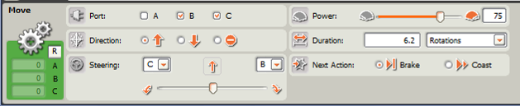

- Save the computer program.
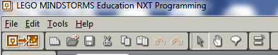
- Download the program onto your robot using the USB cord (robot must be turned on).
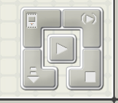
- Disconnect and use the orange button on the robot to run the program.
Discussion questions
What difficulties did you encounter with the programming?

What did you do to overcome these difficulties?

What strategies did you use to figure out the distance from the obstacle to the X in steps 4-5?

What strategies did you use to figure out how to program the robot to turn in step 6?

Why did you need to select “unlimited” for the move block in Step 2?
You needed to select “unlimited” because you didn’t know how away the obstacle was that would activate the ultrasonic sensor.

What other things might use a touch sensor?
Automatic car wash
Touch screens

What other things might use an ultrasonic (distance) sensor?
Bats use ultrasound for navigation.
Many motion detectors use ultrasound (burglar alarms, motion sensing lights).

Scoring Rubric
Task | Points Possible | Points Earned
The robot begins the challenge centered on the X facing toward the obstacle (ultrasonic sensor facing obstacle) | 10
The robot moves toward the obstacle | 10
The robot uses the ultrasonic sensor to detect the obstacle at a distance of 12 inches | 10
Upon sensing the obstacle the robot moves backwards | 10
The robot stops in its original position (centered on the X as in step 1) | 10
The robot spins in place 2 and ½ times such that the touch sensor is now facing the obstacle | 10
The robot moves toward the obstacle | 10
The robot touches the obstacle with the touch sensor | 10
The robot travels back to the X | 10
The robot stops when centered on the X | 10
Total | 100

