Instructor Guide
Challenge Title: Magic Touch
Introduction
This robotic challenge uses a challenge mat. The robot configuration must include the sound sensor and the touch sensor. The obstacle listed on the challenge schematic can be a wall or any other object that will not move when struck by the robot. The participants will not be told the distance from the start box to the corner nor will they be given the distance from the corner to the obstacle. They will need to use trial-and-error to calculate the proper travel duration of the robot. For example, they might have to view how far the robot travels in one tire rotation and then estimate how many rotations it will take to cover the required distance. The youth will also have to use trial-and-error to figure out how to make the robot turn the correct arc distance so the touch sensor is facing the obstacle. They may also reference “Distance and Turns” to estimate how many rotations or degrees it will take to successfully complete the challenge.
Objectives
Youth will demonstrate creativity, innovation and critical thinking skills.
Youth will increase their ability to work collaboratively with others.
Youth will be able to improve communication skills.
Youth will better understand the process of programming and evaluating robotic movements.
Youth will increase their ability to design a solution to a challenge.
Level of Difficulty
Preparation and Materials
Instructor should determine the teaching methodology (as identified in the introduction of this guide) that best fits the audience.
Print appropriate student materials.
Create “Magic Touch” challenge mat using:
Masking or painter’s tape
Measuring tape
Paper or poster board (at least 40 X 20 inches in size)
Obstacle such as a weighted box, heavy book or wall

24 in.
13 in.
START
8 in.
9 in.
17 in.
8 in.
Obstacle or wall

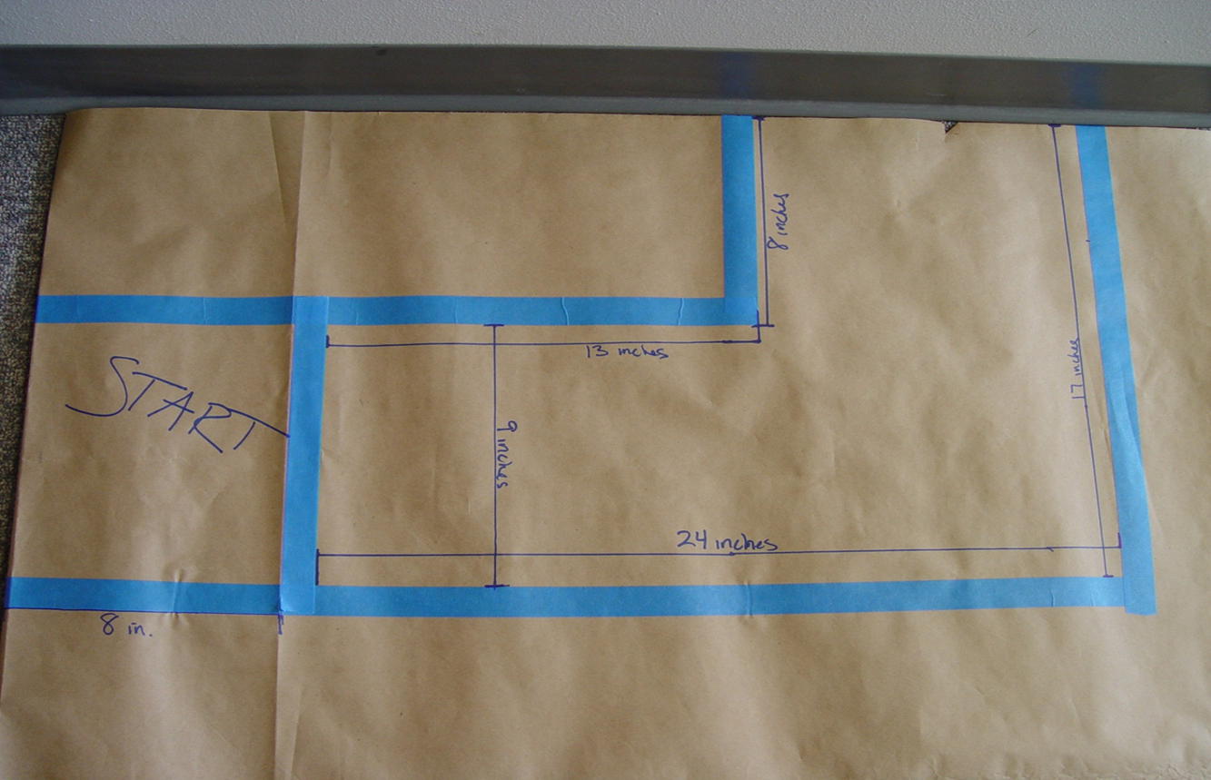

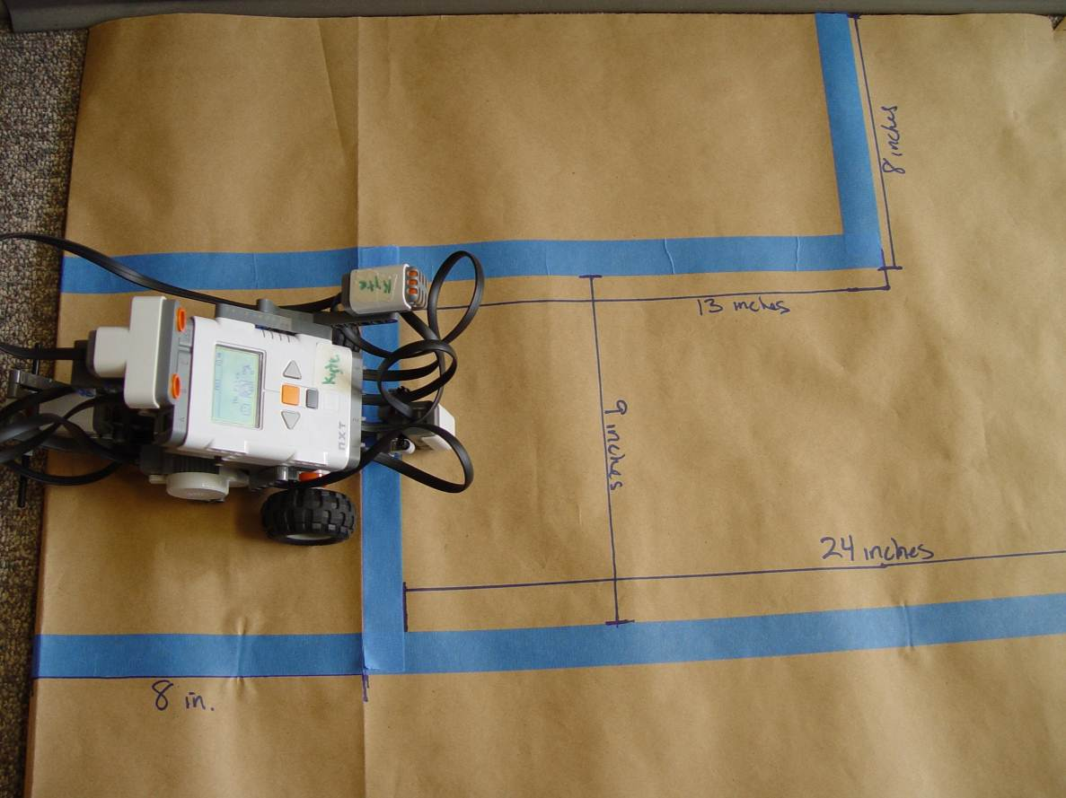

This picture demonstrates the position of the robot in step 1 and at the end of step 6
Time Required
Programming: 30-45 minutes (if participants are given text instructions only)
To run the course: 1-2 minutes
Procedure of Programming Steps
Depending on the expertise level of the participants, the instructor can give the youth the text of the steps involved in the challenge, give them the abbreviated programming guide or give them the entire pictorial programming guide.
TEXT:
- The front wheels of the robot must be completely behind the start line.
- The robot must stay inside the lines at all times.
- The robot moves from the start area to the corner and stops.
- The robot turns when it hears a sound, such that the touch sensor is facing the obstacle.
- The robot touches the obstacle with the touch sensor.
- Once the robot touches the wall it must return to its initial starting position (facing forward and ready to complete the course again).

ABBREVIATED PROGRAMMING GUIDE:
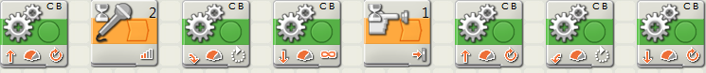
COMPLETE PICTORIAL PROGRAMMING GUIDE:
- The front wheels of the robot must be completely behind the start line.
- The robot must stay inside the lines at all times.
- The robot moves from the start area to the corner and stops.
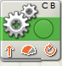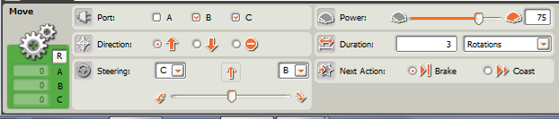
- The robot turns when it hears a sound, such that the touch sensor is facing the obstacle.
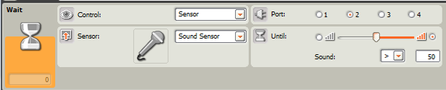
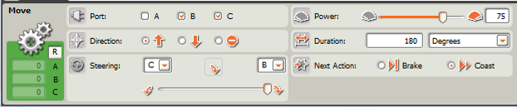
- The robot touches the obstacle with the touch sensor.
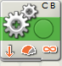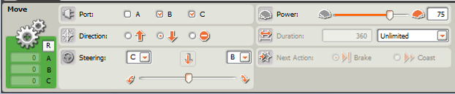
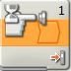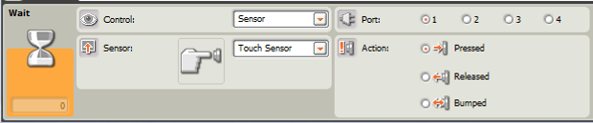

- Once the robot touches the wall it must return to its initial starting position (facing forward and ready to complete the course again).
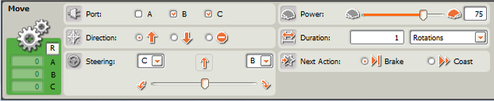

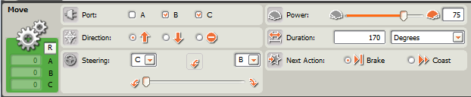

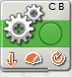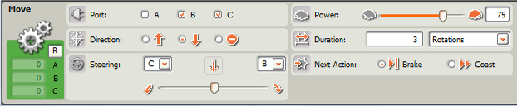
- Save the computer program.

- Download the program onto the robot using the USB cord (robot must be turned on).
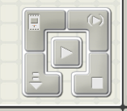
- Disconnect and use the orange button on the robot to run the program.

Discussion Questions
What difficulties did you encounter with the programming?

What did you do to overcome these difficulties?

What strategies did you use to figure out the distance from the start area to the turn corner?

What strategies did you use to figure out how to program the robot to turn in step 4?

Why did you need to select “unlimited” for the move block in Step 5?
You needed to select “unlimited” because you didn’t know how away the obstacle was that would activate the touch sensor.

What other things might use a touch sensor?
Automatic car wash
Touch screens

What other things might use a sound sensor?
Any voice activation software: Siri, etc.
Many new car radios will decrease sound when engine noise is reduced.
Scoring Rubric
Action | Points Possible | Points Earned
The front wheels of the robot must be completely behind the start line | 10
The robot must stay inside the lines at all times | 10
The robot moves from the start area to the corner and stops | 10
The robot turns when it hears a sound, such that the touch sensor is facing the obstacle | 10
The robot touches the obstacle with the touch sensor | 10
Once the robot touches the wall it must return to its initial starting position (facing forward and ready to complete the course again) | 10
Total | 60

