Instructor Guide
Challenge Title: GOAL!! (Modified from 2011 Wisconsin 4-H Robotics Rally Implementation Packet)
Original author: Michelle Grimm, Taylor County 4-H Youth Development
Introduction
This robotic challenge uses a challenge mat. The robot configuration must include the sound sensor. Other sensors may be used throughout the routine to complete the tasks outlined in the challenge. Since there are several ways to successfully complete the challenge, no abbreviated or pictorial programming guide is provided. To successfully complete the GOAL! challenge, the participant must score a goal by knocking the ball off the platform sometime during the program routine. The ball is placed in the middle of the challenge mat by balancing it on three connected Legos as shown in the schematics below. Youth may build the rotating arm, if they wish; however, they may also knock the ball off the platform using any part of the robot. The robot must also touch all corner lines of the field. Both front tires should touch and/or cross the corner lines to exhibit mastery of this challenge.
Objectives
Youth will demonstrate creativity, innovation and critical thinking skills.
Youth will increase their ability to work collaboratively with others.
Youth will be able to improve communication skills.
Youth will better understand the process of programming and evaluating robotic movements.
Youth will increase their ability to design a solution to a challenge.
Level of Difficulty
Preparation and Materials
Instructor should determine the teaching methodology (as identified in the introduction of this guide) that best fits the audience.
Print appropriate student materials.
Create “GOAL!!” challenge mat using:
Masking or painter’s tape
Measuring tape
Paper or poster board (at least 44 X 28 inches in size)
Lego plastic ball (as provided in the LEGO® Mindstorms® NXT v. 2.0 Kit)
Two 1X8 LEGO bricks
One 1X6 LEGO brick
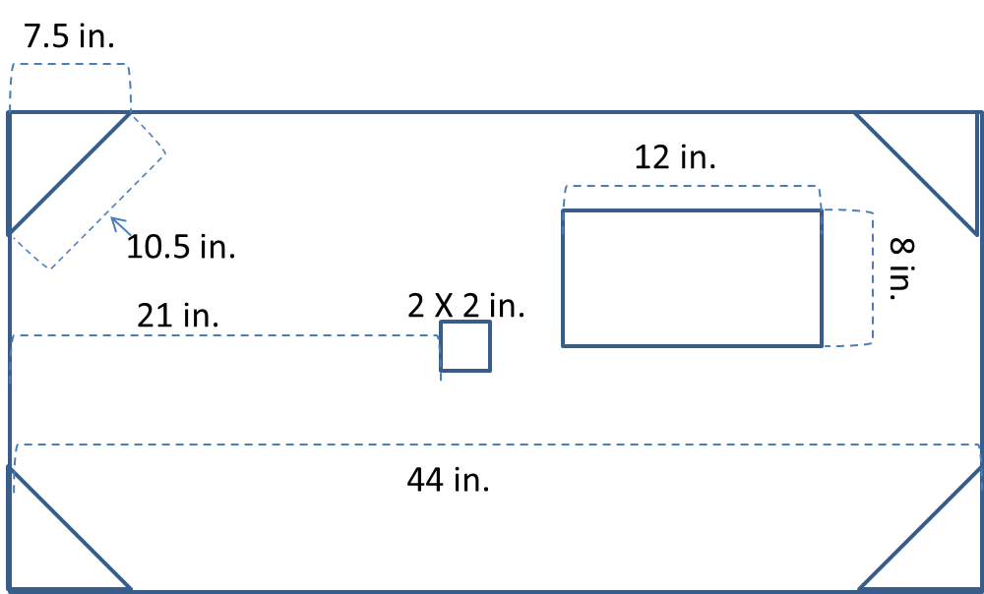
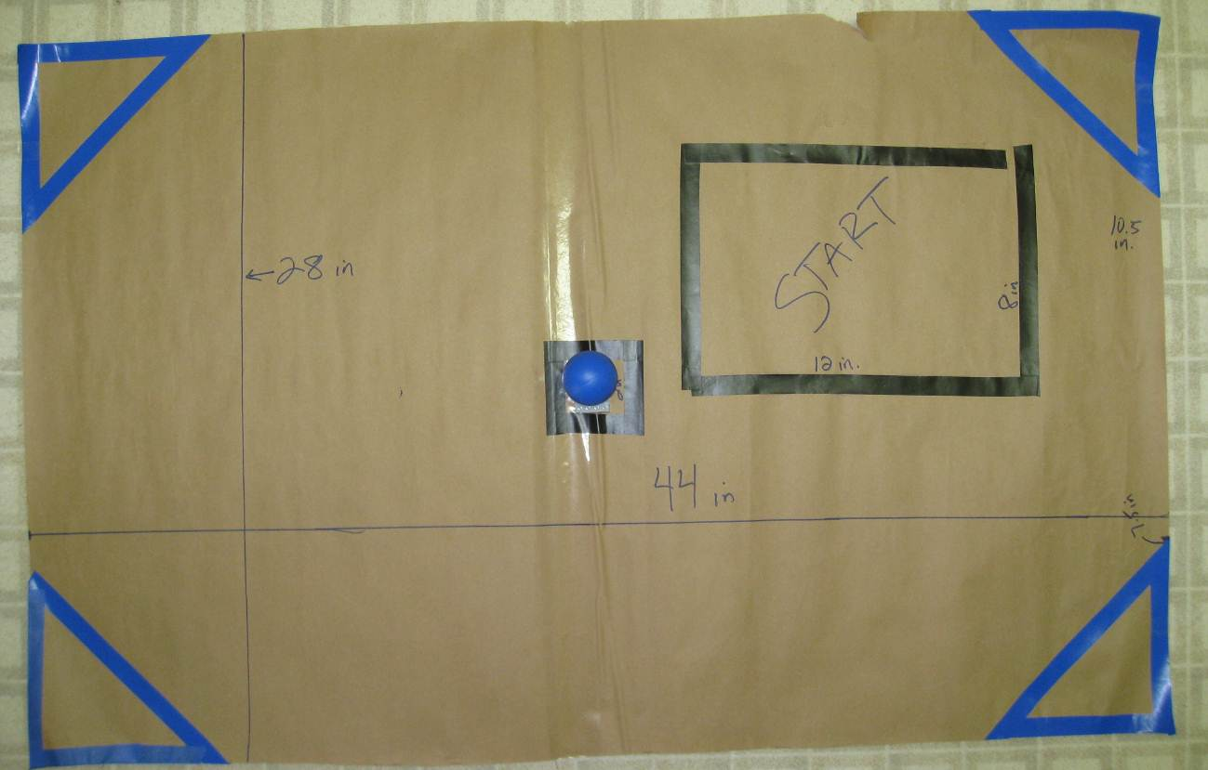
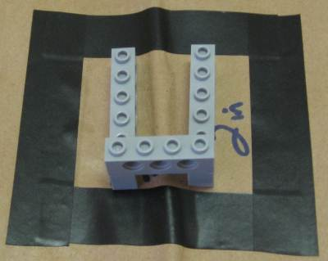
Ball Platform
Time Required
Programming: 3 hours or more
To run the course: 2-3 minutes
Procedure of Programming Steps
Since there are several ways to successfully complete the challenge, no abbreviated or pictorial programming guide is provided. This challenge is meant for advanced youth and will enable them to practice critical thinking, creativity and robotic programming mastery skills.
TEXT:
- The robot begins the challenge completely within the start box.
- The entire robot must stay on the challenge field at all times during the routine.
- The robot must be set in motion with the clap of a hand.
- The robot must now proceed to access each of the corners of the field. The robot must have two wheels within the boundary of each corner of the field without leaving the field.
- The corners can be accessed in any order but all four must be crossed.
- At some time during the routine, the robot must approach the ball stand placed at the center square and score a goal by knocking the ball off the platform. The ball does not need to leave the challenge field, just be removed from the platform.
- At the end of the routine the robot must return to the start box and must announce in some way that it has completed the task. The robot must be entirely within the start box.
Discussion Questions
What difficulties did you encounter with the programming?

What did you do to overcome these difficulties?

Why might you want to wait until you have completed touching all the corners before hitting the ball?
It would be hard to predict where the ball would roll to and the position of the ball might interfere with your routine.
Scoring Rubric
Action | Points Possible | Points Earned
The robot begins the challenge completely within the start box | 10
The entire robot must stay on the challenge field at all times during the routine | 10
The robot must be set in motion with the clap of a hand | 10
The robot must now proceed to access each of the corners of the field. The robot must have two wheels within the boundary of each corner of the field without leaving the field. The corners can be accessed in any order but all four must be crossed
Corner 1 | 10
Corner 2 | 10
Corner 3 | 10
Corner 4 | 10
At some time during the routine, the robot must approach the ball stand placed at the center square and score a goal by knocking the ball off the platform. The ball does not need to leave the challenge field, just be removed from the platform | 10
At the end of the routine the robot must return to the start box and must announce in some way that it has completed the task. | 10
The robot must be entirely within the start box | 10
Total | 100

