Instructor Guide
Challenge Title: Dancing Bot
Introduction
This robotic challenge does not use a challenge mat. In this challenge youth will use a series of blocks to make the robot move forward and make turns while simultaneously playing sound. No sensors are required to complete this challenge; however, youth are encouraged to be creative and use sensors as part of their routine. To successfully complete the challenge, the participant must use at least four different move blocks and three different sounds running simultaneously and have the entire program loop for two minutes.
Youth will be using the idea of simultaneous or parallel programming where two programs run at the same time. In order to create this program, participants must create a secondary sequence beam (the line that connects the programming blocks to one another). Instructors are encouraged to demonstrate how to create parallel programs before youth begin the challenge. The instructor can find information on how to build parallel programs by selecting the “help” link along the software’s top menu toolbar and then selecting “contents and index” and then “sequence beam”. If the instructor does not have access to the internet, one can also find out how to create parallel programs in the complete pictorial guide below (refer to step 3). The instructor should also note that to use the loop programming block, all the blocks one wants to repeat must be inside the loop. This can be done by dragging and dropping the move or sound blocks in the middle of the loop block.
Objectives
Youth will demonstrate creativity, innovation and critical thinking skills.
Youth will increase their ability to work collaboratively with others.
Youth will be able to improve communication skills.
Youth will better understand the process of programming and evaluating robotic movements.
Youth will increase their ability to design a solution to a challenge.
Level of Difficulty:
Preparation and Materials
Instructor should determine the teaching strategy (as identified in the introduction of the guide) that best fits the audience.
Instructor should be prepared to demonstrate the creation of additional sequence beams.
Print appropriate student materials.
Time Required
Programming: 30-60 minutes (if participants are given text instructions only)
To run the course: 2 minutes

Procedure of Programming Steps
Depending on the expertise level of the participants, the instructor can give the youth the text of the steps involved in the challenge, give them the abbreviated programming guide or give them the entire pictorial programming guide.
TEXT:
- The robot will perform four unique dance moves. For example, the robot will move forward, backward, spin or turn.
- The robot will use the loop programing block to repeat the series of dance steps for two minutes.
- The robot will use a parallel sequence beam to play at least three different sounds while performing the dance moves programmed in step 1. Any sounds or notes are acceptable.
- The robot will use the loop programing block to repeat the series of sounds for two minutes.

ABBREVIATED PROGRAMMING GUIDE:
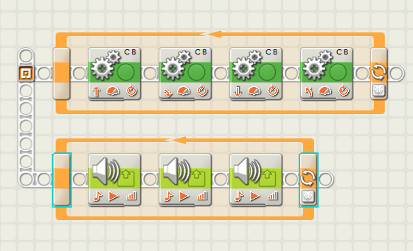

COMPLETE PICTORIAL PROGRAMMING GUIDE:
- The robot will perform four unique dance moves. For example, the robot will move forward, , spin, move backward or turn.

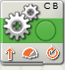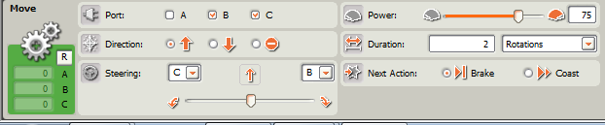
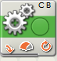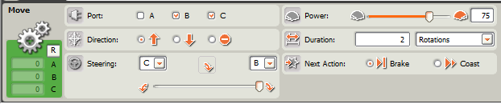
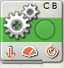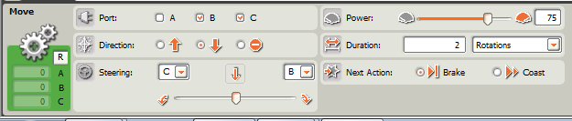
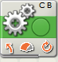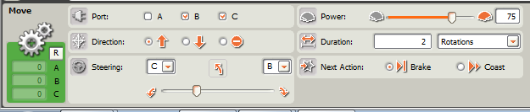

- The robot will use the loop programing block to repeat the series of dance steps for two minutes.
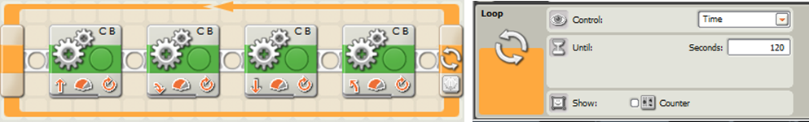

- The robot will use parallel sequence beam to play at least three different sounds while performing the dance moves programmed in step 1. Any sounds or notes are acceptable.

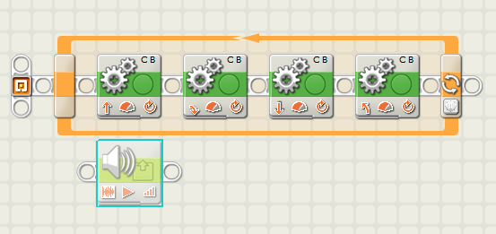
↑
→
← See arrows above
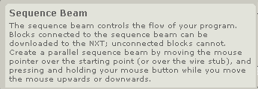
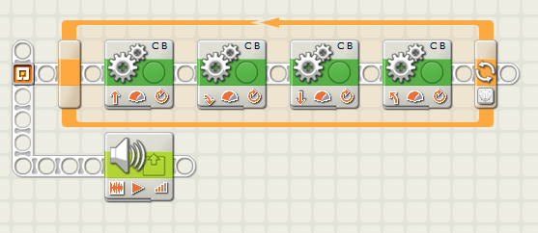

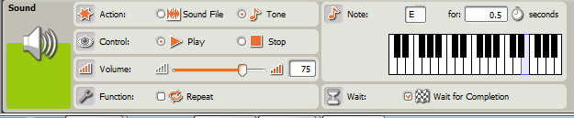
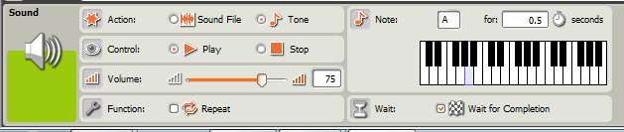
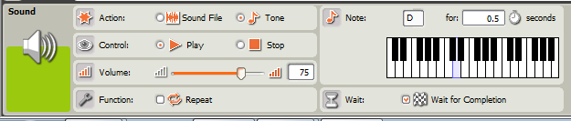

- The robot will use the loop programing block to repeat the series of sounds for two minutes.
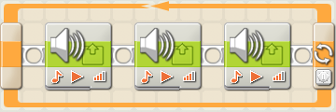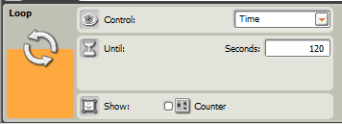

- Save the computer program.
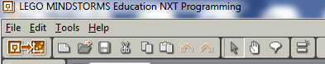

- Download the program onto your robot using the USB cord (robot must be turned on).
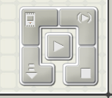

- Disconnect and use the orange button on the robot to run the program.

Discussion questions
What difficulties did you encounter with the programming?

What did you do to overcome these difficulties?

What other things might use simultaneous programming?
Cell phone that can ring & vibrate
Digital alarm clock that keeps time and sounds alarm

Scoring
Action | Points Available | Points Earned
Robot must perform four different dance movements
Movement 1 | 10
Movement 2 | 10
Movement 3 | 10
Movement 4 | 10
Robot must play at least three different sounds
Sound 1 | 10
Sound 2 | 10
Sound 3 | 10
Robot must play sound and move simultaneously | 10
The movements must loop for two minutes | 10
The sounds must loop for two minutes | 10
Totals | 100

