Impact Evaluation:
Nutrition in Early Childhood Programs
in Sauk County
Sus Nagelkirk, University of Wisconsin Extension, September 2013

The Issue and our Response:

Almost one-quarter of America’s preschoolers (ages 2-5) are overweight or obese today. And this predicts a lifetime of obesity and health problems. No wonder that most child care staff want to learn more effective ways to encourage healthy eating in young children.

To answer this need, the Sauk County Extension Office is delivering a series of classes to child care staff from around the county. In the 1st class of the series (in April 2013), 11 child care staff learned how to help children to try and enjoy new foods. Participants included teachers, cooks, and administrators, from programs serving infants through school-aged children.

Accepting new foods:
Eating a variety of nourishing foods is one key to a healthy life, but how do we get children to like new foods?
The workshop emphasized two key strategies: (1) the use of multiple exposures to new foods, and (2) learning from the teacher’s example. Research has confirmed that these two strategies really work. During the class, the instructors modeled how to interact with children, for example, having the participants prepare their own snacks, while the instructor read a children’s picture book about the food in the snack. The participants also had many opportunities to practice the skills they were learning, and to learn from each other about the practices of other child care programs in the community.

1. Children need multiple exposures to a new food, often up to fifteen times before they are willing to eat it, according to research that has tested this idea (Birch et al, 1990). Parents may say, “I gave her a new food, papaya, and she didn’t like it. Then I gave her mangoes and she didn’t like that either. I’m running out of foods!” Exposure to many nutritious foods is the ultimate goal, but trying one food after another is not the best strategy. Research shows that children need repeated exposures to the same food many times before they are likely to eat and enjoy it. One study gave 2-year-olds varying opportunities to taste new fruits or cheeses and found that the children’s preference for the fruit or cheese increased as they were exposed to the food more often (Birch & Marlin, 1982).

In the workshop, Yummy Carrot Sticks! How Children Learn to Like Nutritious Food, early childhood staff learned multiple ways to introduce new foods to children. For instance, new foods can be introduced by having children help grow or cook them, taking a field trip to a grocery store or farmers market, reading books about the food, and “taste testing” them at snacks and meals. Repeated, positive exposures to new foods in the company of trusted adults help children feel comfortable in trying new foods. Early Childhood professionals who attended the workshop said they intended to encourage children to try new foods in the following ways:

* I think we’ll try the sample plate to give them a choice of what they like best.

* I will have them watch me prepare it.

* We can have a book to go along with the food.

* Taste testing.

* Have them serve themselves.

2. Children learn from the example of their teachers. In other parts of the world, children learn to like almost any food they see their parents and others enjoy, including foods our own children would consider very odd (for example insects or raw fish). Researchers have tested this idea, and found that
children really do watch the faces of adults very closely at the meal table, and often imitate the reactions they see (Roberts & Heyman, 2000). If an adult wrinkles up their nose or looks uninterested in a food, the child will often imitate the reaction.

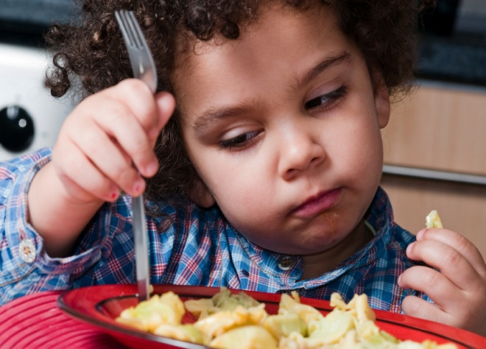

While the participants in the workshop already knew this, they learned that they could be more consistent and careful in their reactions to food. During the workshop, the varied reactions of participants to tofu were observed and reported back to them, which helped them see how much self-control they might need to use when trying new foods with the children!

Early Childhood programs can be especially influential at introducing children to new foods because their peers are there too. One study found that children were more willing to try a vegetable they previously had disliked if they saw other children choosing to eat it (Birch, 1980).

When asked what they intended to do differently in their programs, the workshop participants mentioned several ways they would try to role model an interest in new foods:

* Be positive (about new foods).

* I will eat with them.

* Try new foods with them.

In summary, child care professionals who attended the workshop thought they learned a lot, and intended to change their practices.

- Wonderful workshop. I walked away with many new ideas.

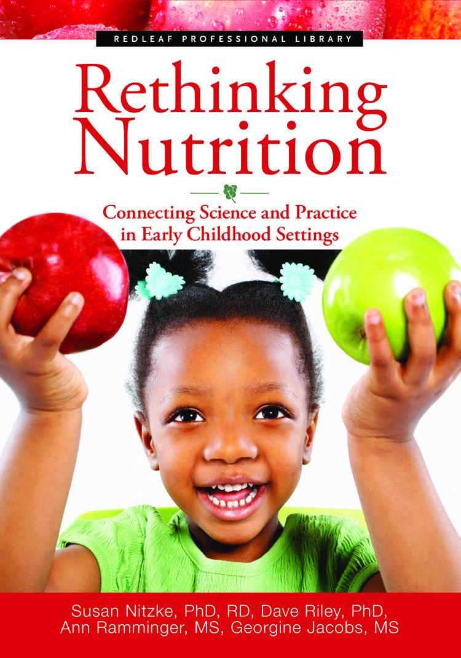

Source: The main source material for this workshop was a book written by 2 UW-Madison professors and 2 Wisconsin early childhood professionals:

Nitzke, S., Riley, D., Ramminger, A., & Jacobs, G. 2010. Rethinking Nutrition: Connecting Science and Practice in Early Childhood Settings. St. Paul: Redleaf Press.

References:

¹ Birch, L.L., McPhee, L., Steinberg, L., & Sullivan, S. (1990). Conditioned flavor preferences in young children. Physiology and Behavior, 47: 501-505.

² Birch, L.L., & Marlin, D.W. (1982). I don’t like it: I never tried it: Effects of exposure to food on two-year-old children’s food preferences. Appetite, 4: 353-360.

³ Roberts, S.B., & Heyman, M.B. (2000). How to feed babies and toddlers in the 21st century. Zero to Three, 21(1): 24-28.

⁴ Birch, L.L. (1980). Effects of peer models’ food choices and easting behaviors on preschoolers’ food preferences. Child Development, 51: 489-496.

Contact:
Sue Nagelkirk
UW-Extension, Family Living
West Square Administration Bldg
505 Broadway
Baraboo, WI 53913-2404

608-355-3256
susan.nagelkerk@ces.uwex.edu

