Impact Evaluation:



**Nutrition in Early Childhood Programs**

**in Marinette County**

Nancy Crevier, University of Wisconsin Extension, June 2013

***The Issue and our Response:***

Almost one-quarter of America’s preschoolers (ages 2-5) are overweight or obese today.  And this predicts a lifetime of obesity and health problems. No wonder that most child care staff want to learn more effective ways to encourage healthy eating in young children. To answer this need, the Marinette County Extension Office is delivering a four-part series of classes to child care staff from around the county.

***Impact on targeted skills:***

In the 2nd class of the series (in May 2013), 23 child care staff learned not only the importance of increasing consumption of whole grains, fruits, vegetables, and low-fat proteins, and reducing the intake of added sugars, but they also learned crucial skills:

* how to read actual product labels and estimate the amounts of these ingredients in common snack foods for children,
* and how to modify children’s snacks to make them more healthy.

Participants in the class included child care directors, cooks, teachers, and family child care providers. They were tested before and after the class, and demonstrated dramatic improvements in these skills.

As shown in the figure on the next page, the Extension class led to many child care staff learning how to correctly identify whole grains and sugars on real product labels.

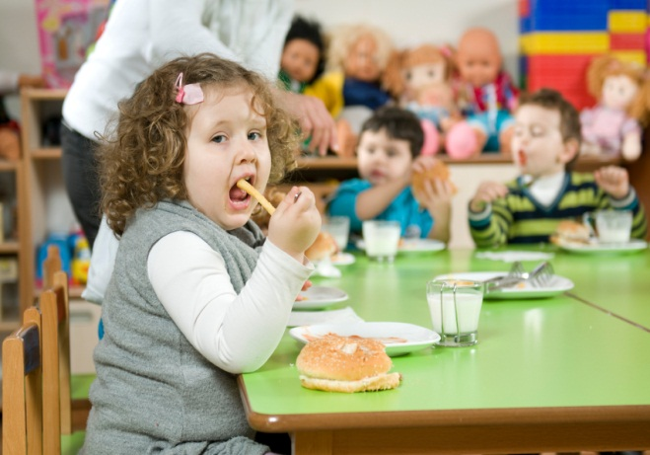

Only 17% of participants had the ability to correctly identify the 5 whole grains in 4 product labels prior to the class (with one or no errors). Following the class, 74% of participants had this ability.

The variety of names that sugars are listed under make them especially hard to identify on product labels, and only 43% of participants could do this with 4 or fewer errors. The class doubled this percentage, to a 78% rate of competency.

And when asked what they would look for in a healthier granola bar (one of the 4 tested items), they had no difficulty answering:

* *Whole grains, fruit, and a lot less sugar.*
* *No corn syrup or added sugars.*
* *Less added sugar, more whole grains.*

This is strong evidence of real skills having been learned.

***Participants gained ability to accurately read a food product label.***

1. Percentage identifying the 5 whole grains on 4 ingredient labels, with one error or less. Pretest = 17%, Posttest = 74%.

2. Percentage identifying the 11 sugars on 4 ingredient labels, with 4 errors or less. Pretest = 43%, Posttest = 78%.

***Research on childhood obesity***

Since 1970, the number of 2-5 year olds who are considered obese has more than doubled.1 Twice as many children are now identified as having the highest level of body fat for their height and age.

Not only are more children obese and overweight but overweight children also may not be getting the nutrients they need to be healthy. In their study of toddlers in the United States, Briefel and colleagues2 found that toddlers consume too many calories, especially from foods and beverages that are high in sugar, and eat too few fruits and vegetables.

Another study3 about toddler nutrition found that a quarter of toddlers had no vegetables on the day studied (excluding french fries). Children who eat enough calories but do not eat enough vegetables, fruits, whole grains, and low-fat proteins actually have some of the diseases of malnutrition (like failing eyesight or poor bone structure) even though they look to be a healthy weight.4

The adults in children’s lives, such as parents and child care teachers, play an important role in exposing children to nutritious foods. Since children receive anywhere from 1/3 to 2/3 of their daily nutritional needs during child care,5 the nutritional quality of meals and snacks served in child care settings is essential to children’s health. Currently, research shows that time spent in child care is associated with increased waist size and obesity (BMI) in children,6 but this could change if child care staff receive training like that in this Extension program .

When children are served foods high in fat and sugar, they are more likely to overeat.7 To help prevent children from overeating, early childhood programs can serve meals and snacks made primarily of fruits, vegetables, whole grains, and low-fat proteins like chicken or beans. Additionally, eliminating sugar-sweetened beverages from early childhood menus and instead serving water, milk or 100% juice can help children maintain a healthy weight over time.8

***The Extension Class***

In the workshop, *What’s for Snack? Nutrition to Support Healthy Growth*, child care staff learned what meals and snacks promote good nutrition. During the workshop participants talked about the foods they usually feed children in their programs, learning some good ideas from each other.

They also practiced reading food labels from real snack foods for children and learned ways to identify foods high or low in whole grains and sugars. Minimizing children’s exposure to foods high in sugar can help children choose to eat more nutritious foods.

Child care professionals who attended the workshop thought they learned a lot, and intended to change their practices.

* *Great class, I learned a lot!*
* *I found this class very informative and would recommend it to others.*

***Sources:***

1 National Center for Health Statistics. (2012). Prevalence of obesity among children and adolescents: United States, Trends 1963-1965 through 2009-2010. *Health E-Stat, September*. Accessed March 15, 2013 at <http://www.cdc.gov/nchs/data/hestat/obesity_child_09_10/obesity_child_09_10.htm>

2 Briefel, R. R., Reidy, K., Karwe, V., & Devaney, B. (2004). Feeding infants and toddlers study: Improvements needed in meeting infant feeding recommendations. *Journal of American Dietetic Association, 104*: 31-37.

3 Devaney, B & Fox, M. K. (2008). Dietary intakes of infants and toddlers: Problems start early. In *Eating behaviors of the young child: Prenatal and postnatal influences on healthy eating*. (Eds. Leann Birch and William Deitz). Elk Grove Village, IL: American Academy of Pediatrics.

4 Ebbeling, C. B., Pawlak, D. B., & Ludwig, D. S. (2002). Childhood obesity: public-health crisis, common sense cure. *Lancet, 360*: 473-482.

5 American Dietetic Association. (2005). Position of the American Dietetic Association: Benchmarks for nutrition programs in child care settings. *Journal of the American Dietetic Association, 105*: 979-986.

6 Benjamin, S. E., Rifas-Shiman, S. L., Taveras, E. M., Haines, J., Finkelstein, J., Kleinman, K., & Gillman, M. W. (2009). Early child care and adiposity at ages 1 and 3 years. *Pediatrics, 124*: 555-562.

7 Leahy, K. E., Birch, L. L., & Rolls, B. J. (2008). Reducing the energy density of multiple meals decreases the energy intake of preschool-age children. *American Journal of Clinical Nutrition, 88*: 1459-1468.

8 Fiorito, L. M., Marini, M., Francis, L. A., Smiciklas-Wright, H., & Birch, L. L. (2009). Beverage intake of girls at age 5 y predicts adiposity and weight status in childhood and adolescence. *American Journal of Clinical Nutrition, 90*: 935-942.

***Contact:***

Nancy Crevier

Family Living Educator

Marinette County – UW Extension  
Courthouse, 1926 Hall Avenue  
Marinette, WI

54143-1717

715-732-7510

[nancy.crevier@ces.uwex.edu](mailto:nancy.crevier@ces.uwex.edu)



