Be resilient: s-t-r-e-t-c-h, bounce back & roll forward!
29. AUG, 2011
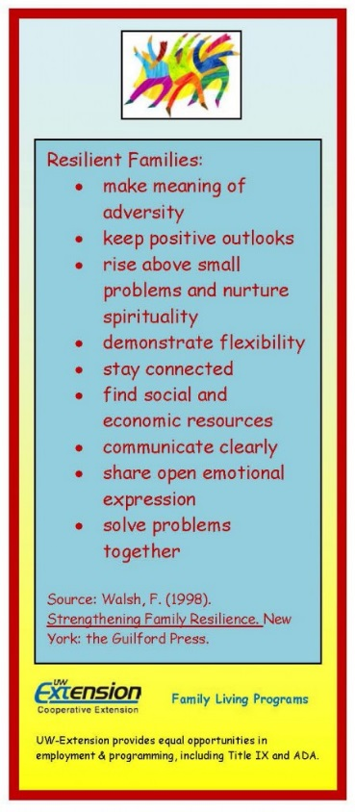

Keys to Resilience: Transformation through Adversity
Resilience is a common word and many of us have a sense that being resilient is a good thing. But what does resilience really mean? And how can being resilient benefit families and individuals, especially when faced with challenges in life?
Resilience can be defined as the capacity to rebound from adversity stronger and more resourceful. It’s important not to equate resilience with competent functioning. Resilience is more than just “getting through” or coping with a challenging situation. Resilience involves positive transformation and growth that enables one to deal effectively with challenges.
One way to think of resilience is to compare it to a rubber band. In order for a rubber band to move
forward we need to pull it back first. The same thing happens in life. Something might happen that knocks us back for a while but, if we are resilient, we stretch ourselves and spring forward.
Froma Walsh developed a family resilience framework that can be useful for families and individuals who are dealing with adversity. Her approach is based on research and has been developed, refined and reformulated over many years of clinical teaching, supervision, and direct practice as a family therapist.
According to Walsh, the family resilience framework applies to various types of family structures as well as formal and informal kin networks. Research has found that families can flourish and children thrive in a variety of kin arrangements; what matters most are effective family processes that contribute to resiliency. The framework can also apply to individuals in the context of their biological or created family.
Walsh offers nine “keys to resilience” in three different areas: family belief systems, family organization and resources, and family communication. When considering any of these keys to resilience it’s important to acknowledge that cultural differences could affect how these ideas look in any particular family.
In the area of family belief systems, resilient families:
- Make meaning of crisis and challenge
Resilient families view crisis as a shared challenge, in contrast to a philosophy of the “tough, rugged individual” getting through adversity. Relationships are extremely important in these families. They believe that by joining together with family members and others who are significant to the family, they can strengthen their ability to meet challenges. Resilient families see adversity as manageable and meaningful, something that contributes to growth and change across the life cycle of the family.
- Maintain a positive outlook
Resilient families hold an optimistic view of life. By affirming family strengths and potential in the midst of crisis, families encourage their members and reinforce a sense of confidence and a “can do” spirit. Resilient families “master the art of the possible,” taking stock of the crisis situation and focusing the family’s energies on making the best of available options. This also implies acceptance of things that are beyond the family’s control.
- Value transcendence and spirituality
Resilient families find meaning, purpose and connection to something beyond themselves, their members, and their immediate problems. This may be defined as the family’s moral and spiritual values that are their source of strength. Many families find strength, comfort and guidance in adversity through their connections with cultural and religious traditions. Families may also find spiritual nourishment through such things as a deep connection with nature, music or art. By seeing themselves as part of something bigger than themselves families are able to take a larger view of the crisis that they are experiencing, which can lead to a heightened sense of purpose in their lives.
In the area of family organization and resources, resilient families are:
- Flexible
Resilient families have a flexible structure that they can modify to fit their needs and challenges, rather than holding a rigid conception of family roles and rules. This allows the family to adapt to changes which may come about through crisis or adversity. While people often refer to “bouncing back” after a crisis, resilience might be seen as “bouncing forward.” Resilient families rebound and reorganize in the face of challenge, rather than returning to the way things were before the crisis. Strong leadership with a focus on security and some sense of predictability is needed within the family to help guide vulnerable family members through changes in the family.
- Connected
Resilient families know they can count on each other during times of crisis. At the same time, family resiliency is strengthened when members respect each others’ individual differences, separateness, and boundaries. Resilient families are able to balance connectedness and separateness among family members in order to respond to changing situations within the family.
- Supported by social and economic resources
Resilient families have a network of people (family, friends, neighbors) and organizations that can serve as their lifelines during challenging times. This network provides practical assistance (information, concrete services), emotional support, and connection to the larger community. Resilient families are able to recognize when they need help and make use of their network to get the help they need.
In the area of family communication, resilient families:
- Share clear, consistent messages
Resilient families “say what they mean and mean what they say.” Communication that is direct, clear, specific, consistent and honest helps all family members understand the crisis that the family is facing and encourages them to share their feelings and opinions with one another. This type of communication also sets the stage for a shared process of decision making about how the family will go forward in the face of crisis.
- Openly express their emotions
Resilient families are characterized by a climate of mutual trust and encourage their members to share a range of feelings, practice empathy, and comfort one another. Resilient families look for opportunities to enjoy humor and pleasurable interactions that can serve as respite during challenging times. Encouraging family members to laugh with one another or to enjoy a pleasurable activity together can revitalize families who are under stress.
- Use collaborative problem solving
Resilient families identify problems and the options available to deal with them and then make decisions as a team. Family members engage in creative brainstorming as a way to discover new possibilities for overcoming diversity, with ideas of all members respected and valued. Resilient families focus on achievable goals and concrete steps that can be taken to achieve those goals. Families build on their success as they pursue their goals and learn from things that don’t work. Through this process, families learn skills that can help them become proactive in preparing for future challenges.
Prepared by: Patti Herman, Pam Peterson and Jane Schaaf, Family Living Educators, UW-Extension, 2009.
Resource: Walsh, F. (2006) Strengthening Family Resilience (Second Edition). New York: The Guilford Press
University of Wisconsin-Extension, U.S. Department of Agriculture, and Wisconsin counties cooperating. UW-Extension provides equal opportunities in employment and programming, including Title IX and ADA

