

**What? So What? Now What?**

This strategy is based on experiential learning and reflection models. When our learners have real-world experiences, a practical way to elicit reflection is to use the “What, So What, Now What” model.

**What:**  Describe the experience in detail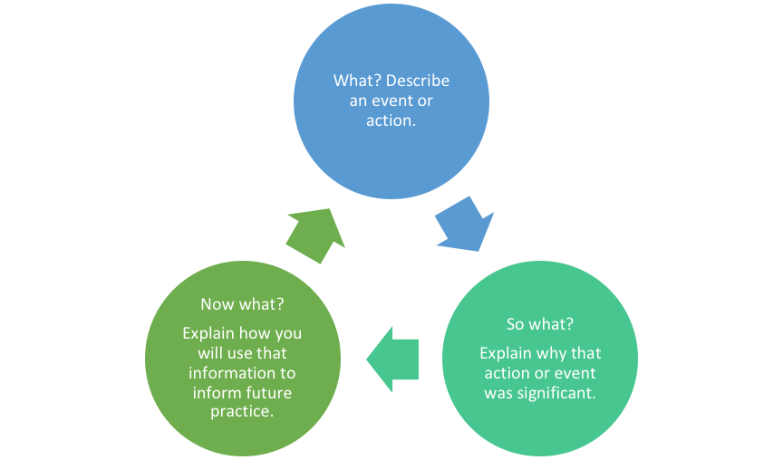

* What happened? What did you observe?
* What was your role?
* What were your initial expectations?
* What was good/bad about the experience?
* What did you learn from the experience?
* What part of your experience was most challenging?
* What part did you find surprising?

**So What**? Describe the significance of the event

* What about the event stuck out to you/made an impact on you?
* What emotions does it evoke? How does it make you feel?
* What broader issues arise from the situation at hand?
* What conclusions can you draw from the experience?
* What did you learn about others and yourself?
* How were you different when you finished this experience?
* How were you different/similar to other people involved? How did being different help/hinder?
* What values, opinions, decisions have been made or changed through this experience?
* What new skill did you learn?
* How did this experience clarify, expand, or create an interest?

**Now What?** Describe the next steps

* How will you apply what you learned from your experience?
* What would you like to learn more about, related to this project or issue?
* What information can you share with your peers or the community?
* If you could do the project again, what would you do differently?
* Where do you go from here? What is the next step in the process?

<https://cetl.uconn.edu/what-so-what-now-what-model/#>

[Critical Reflection](https://www.researchgate.net/profile/Paula_Williams8/publication/303681619_Campus-based_work-integrated_learning_Opportunities_for_Health_Education/links/574d0a5c08aec988526a2851/Campus-based-work-integrated-learning-Opportunities-for-Health-Education.pdf#page=163)

<https://johndabell.com/2018/08/05/models-of-reflection/>