**Speed Sharing & Give One - Get One**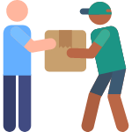

**(adaptable)**

**Instructions:** line (or circle) up so that each person has a partner opposite them. At the beginning of the round, share your favorite app with your partner. They will share their favorite with you. Write them down if you’d like.

At the end of __ minutes, you will hear a sound, at which point, the outer ring (east-facing line, etc.) will rotate one position. Continue until you have spoken with each partner!

|  |  |
| --- | --- |
| My Favorite _______________________________ (food ingredient, song, app, memory, etc.) | Give One: _________________________________ (piece of advice, tip, idea, app, etc.) |
| Others favorites: | Get one:   |  |  |  | | --- | --- | --- | |  |  |  | |  |  |  | |  |  |  | |  |  |  | |  |  |  | |  |  |  | |