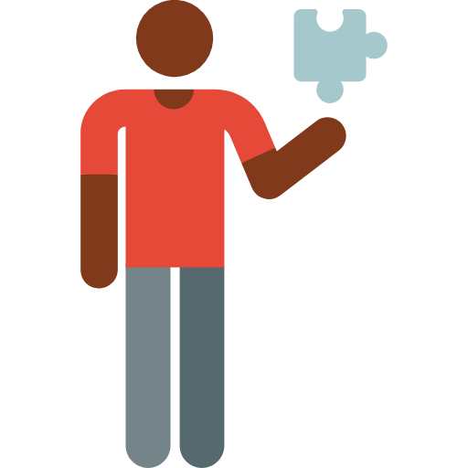

**Jigsaw**

Jigsaw is a collaborative learning strategy. Learners depend on one another for their learning. There are several variations on the basic jigsaw, which you can read more about by checking out the resources below.

(* little-known fact, this strategy was created to cool racial tensions in the 1970s around school desegregation)

Here’s how the basic version works:

Learners are divided into groups who will become topic experts around a specific chunk of the content.

They have time to work individually and as a group to master the content. They practice “teaching” that content to others by articulating, drawing, writing, etc.

Learners are then re-grouped such that there is one content expert for each topic within the new group. Learners teach and learn from one another. Accountability for learning is measured as a group (although there are different methods of assessment)

|  |  |
| --- | --- |
| **Potential benefits:**  Cooperation is emphasized and required at both stages of learning.  Experts may learn from other experts, “compare notes” with no penalty. This is highly encouraged.  Social-emotional learning is practiced  Question-asking becomes important, both in order to anticipate from others and to ask of “experts” | **Potential barriers:**  Language barriers  Differences in learner abilities, experiences, prior knowledge  Time and space  Balancing the numbers in groups, if topics to participants do not distribute evenly. |

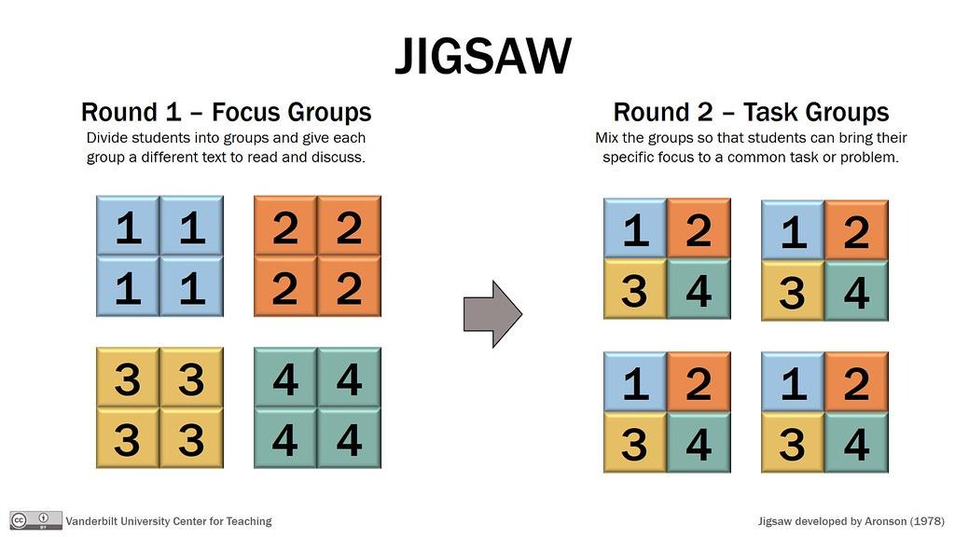

<https://www.cultofpedagogy.com/jigsaw-teaching-strategy/>

<https://www.jigsaw.org/pdf/JigsawBasics.pdf>