**Positive Youth Development Programs: 4-H & Community Youth Development**

**Individual Outcomes**

**4-H** provides membership programs that provide youth members with a comprehensive positive youth development opportunity for youth aged 5-19 supported by families and volunteers. 4-H program outcomes are generally framed as individual youth outcomes.

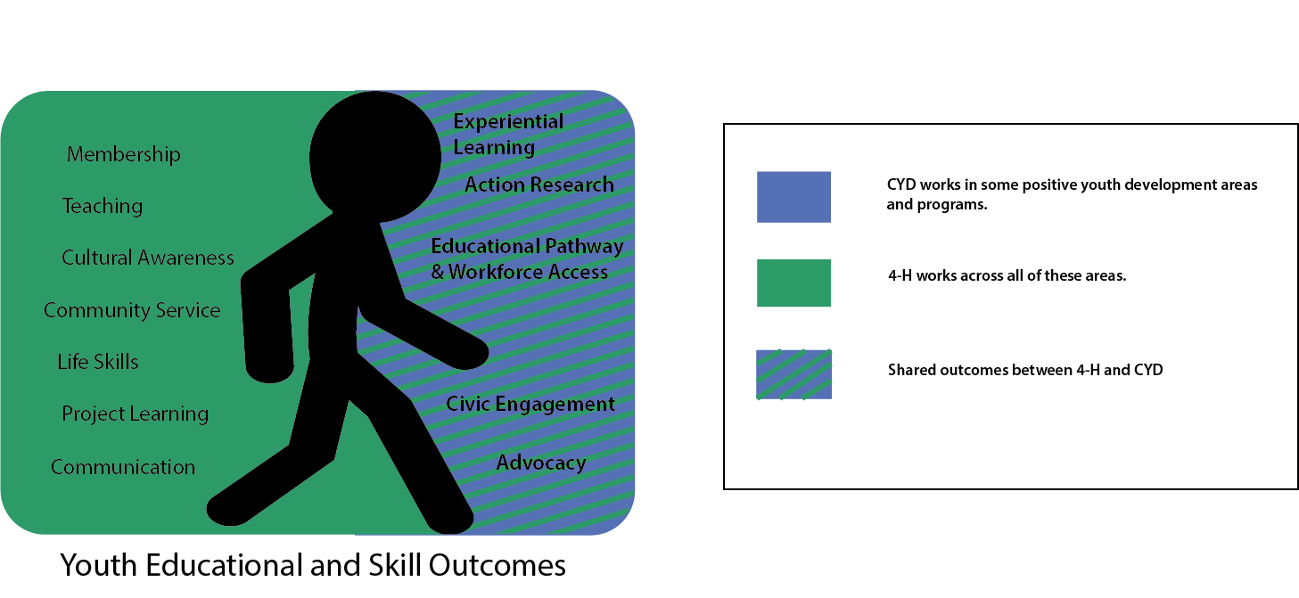**Community Youth Development** programs emphasize youth program objectives focused on community connections and youth voice and action and are generally appropriate for an adolescent audience. CYD program outcomes are often framed as organizational or community outcomes.

**Audiences**

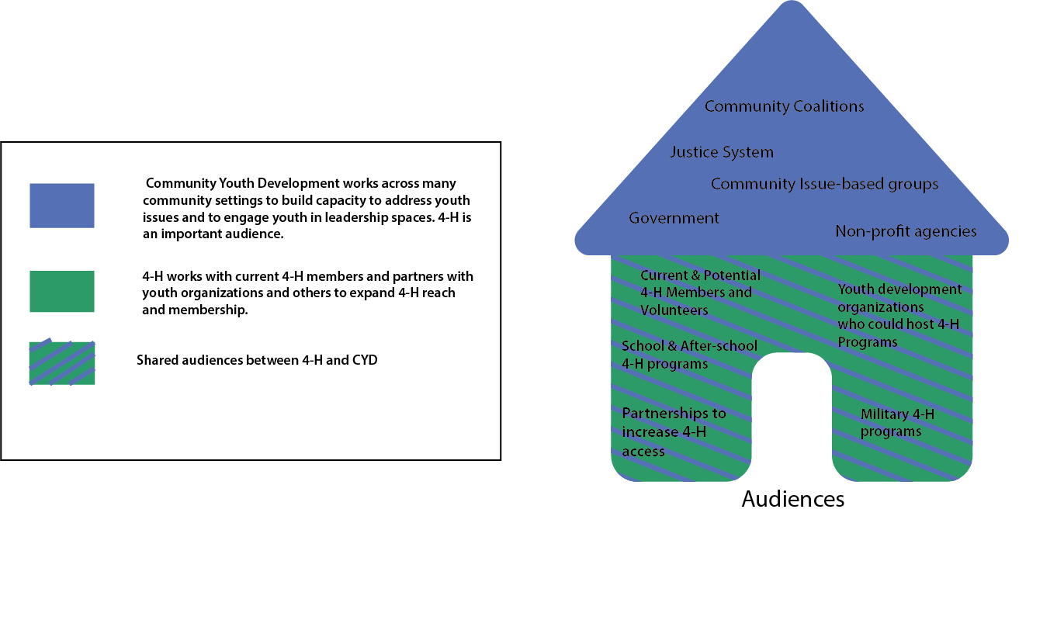

While CYD has a primary focus on community capacity building and youth voice, 4-H staff also work with partnerships to create positive youth development opportunities for all youth and to expand connections for 4-H programs. 4-H programs can be a model for others in positive youth development. And CYD staff may build 4-H membership opportunities into educational programming they develop and support.

|  |  |
| --- | --- |
| **Positive Youth Development (PYD)** | |
| **Wisconsin 4-H Program Model** | **Community Youth Development (CYD)** |
| The **development** of the 5cs of caring/compassion, competence, character, connection and confidence  An **asset based approach** that provides active support for the growing capacity of young people.  A **planned set of activities** (programs)that foster the growing capacity of young people. | Emphasizes a 6th C of youth Contribution to families, neighborhoods and communities using the other 5 C’s.  Focuses on collaboration and **partnerships for the development of communities.**  Program environments incorporate the developmental components to the left. |
| Focuses on the development of the individual young person or persons. | Focuses on the *interaction* of the individual with his or her environment (family, school, community, etc) |
| Can be a springboard or precursor for providing CYD efforts but also provides meaningful and positive development within its programs | Youth become active partners in their own development as well as in their community’s development. |
| The WI 4-H Youth Development Program includes many components that promote CYD including Educational Pathway and Workforce Access, Civic Engagement and Advocacy. | CYD works across community settings to build capacity to address youth issues and to engage youth in leadership spaces. 4-H is an important audience/setting. |
| Generally framed as individual youth outcomes. | Generally framed as organizational or community outcomes. |
| Generally reaches a large span of youth ages (K-Young Adult) | Generally reaches an adolescent and young adult audience. |
|  | |
| **Positive Youth Development (PYD) Institute Staffing Roles** | |
| **4-H Program Coordinator Role** | **CYD Extension Educator Role** |
| Staff manage linkages between the Extension Institutes, other community resource offerings and 4-H programs. | |
| Staff identify opportunities to connect non-traditional partners with 4-H directly or through MOUs to expand the reach of 4-H | |
| 4-H Membership Recruitment, including marketing, reaching diverse and underserved audiences | Assessing community needs related to the positive development of youth. |
| 4-H Volunteer Recruitment, Development and Management | Building community capacity to address issues that affect youth |
| 4-H Club/Group Management – including oversight for educational programming, policy and risk management, and financial reporting and accountability | Leading initiatives and collaborating with organizations to respond to youth issues |
| Locally Relevant and Responsive 4-H Program and Project Development - supporting program quality and evaluating and reporting program results | Linking to university resources or directly providing youth development education and training to youth-serving organizations *including* the 4-H program |
| Connect members and clubs to countywide, state, and national opportunities provided by 4-H and others. | Engaging young people in addressing community needs |
| Engage in external partnerships to support youth outcomes, or, for the purpose of expanding 4-H engagement | Promote youth-adult partnerships and elevate youth voice, especially in traditionally adult spaces |
| Serve as a model and resource for the development of positive youth development programs in the community. |  |

|  |  |
| --- | --- |
| **Positive Youth Development (PYD) Program Focus** | |
| **Wisconsin 4-H Program Model** | **Community Youth Development (CYD)** |
| The **development** of the 5cs of caring/compassion, competence, character, connection and confidence  An **asset based approach** that provides active support for the growing capacity of young people.  A **planned set of activities** (programs)that foster the growing capacity of young people. | Emphasizes a 6th C of youth Contribution to families, neighborhoods and communities using the other 5 C’s.  Focuses on collaboration and **partnerships for the development of communities.**  Program environments incorporate the developmental components to the left. |
| Focuses on the development of the individual young person or persons. | Focuses on the *interaction* of the individual with his or her environment (family, school, community, etc) |
| Can be a springboard or precursor for providing CYD efforts but also provides meaningful and positive development within its programs | Youth become active partners in their own development as well as in their community’s development. |
| The WI 4-H Youth Development Program includes many components that promote CYD including Educational Pathway and Workforce Access, Civic Engagement and Advocacy. | CYD works across community settings to build capacity to address youth issues and to engage youth in leadership spaces. 4-H is an important audience/setting. |
| Generally framed as individual youth outcomes. | Generally framed as organizational or community outcomes. |
| Generally focuses on school-aged youth. | Generally reaches an adolescent and young adult audience. |
| **Positive Youth Development (PYD) Institute Staffing Roles** | |
| **4-H Program Coordinator Role** | **CYD Extension Educator Role** |
| Staff manage linkages between the Extension Institutes, other community resource offerings and 4-H programs. | |
| Staff connect non-traditional partners with 4-H directly or through agreements/MOUs to expand the reach of 4-H. | |
| 4-H Membership Recruitment, including marketing, reaching diverse and underserved audiences | Assess community needs related to the positive development of youth. |
| 4-H Volunteer Recruitment, Development and Management | Build community capacity to address issues that affect youth |
| 4-H Club/Group Management – including oversight for educational programming, policy and risk management, and financial reporting and accountability | Lead initiatives and collaborate with organizations to respond to youth issues |
| Locally Relevant and Responsive 4-H Program and Project Development - supporting program quality and evaluating and reporting program results | Link to university resources or directly provide youth development education and training to youth-serving organizations *including* the 4-H program |
| Connect members and clubs to countywide, state, and national opportunities provided by 4-H and others. | Engage young people in addressing community needs |
| Engage in external partnerships to support youth outcomes, or, for the purpose of expanding 4-H engagement | Promote youth-adult partnerships and elevate youth voice, especially in traditionally adult spaces |
| Serve as a model and resource for the development of positive youth development programs in the community. |  |